01st May 2018

YOKOHAMA’s ADVAN Sport V105 to Come Factory-Equipped on the new BMW M5

YOKOHAMA is now supplying its global flagship “ADVAN Sport V105” tyres to Germany’s BMW Group for use as original equipment on the automaker’s new M5 model. The new BMW M5, which debuted in March 2018 released in markets around the world, will come equipped with tyres 275/40ZR19 (105Y) for front and 285/40ZR19 (107Y) for rear.
The “ADVAN Sport V105” is a high-performance tyre developed by YOKOHAMA primarily for use on high-power premium automobiles. The tyre delivers excellent driving performance combined with superior comfort and safety characteristics. The tyres being supplied for the new BMW M5 were jointly developed with BMW and bear the German automaker’s star marking of approval on the tyre sidewall. In addition to being selected as original equipment for the BMW M5, the “ADVAN Sport V105” also comes factory-installed on the BMW X3, which debuted in November 2017, as well as top-line high-performance models from other leading global automakers.
YOKOHAMA also supplies its high-performance racing tyres to BMW racing teams that to date have achieved great success on YOKOHAMA tyres. Schnitzer Motorsport’s BMW M3 captured the first World Touring Car Championship in 1987 and also won the European Touring Car Championship in 1988. BMWs running on YOKOHAMA tyres have also won a combined total of five 24-Hours Nürburgring and Spa-Francorchamps 24 Hours races, two of the world’s elite road endurance races. In Japan, a BMW 635CSi running on YOKOHAMA tyres captured the first All-Japan Touring Car Championship Class 3 title in 1985. GSR&Studie with Team Ukyo captured the GT300 class series championship in the 2011 SUPER GT series. Studie AG has been a BMW support team since 2014 and has been a BMW works team from 2016 to 2017. YOKOHAMA provided support until 2017.

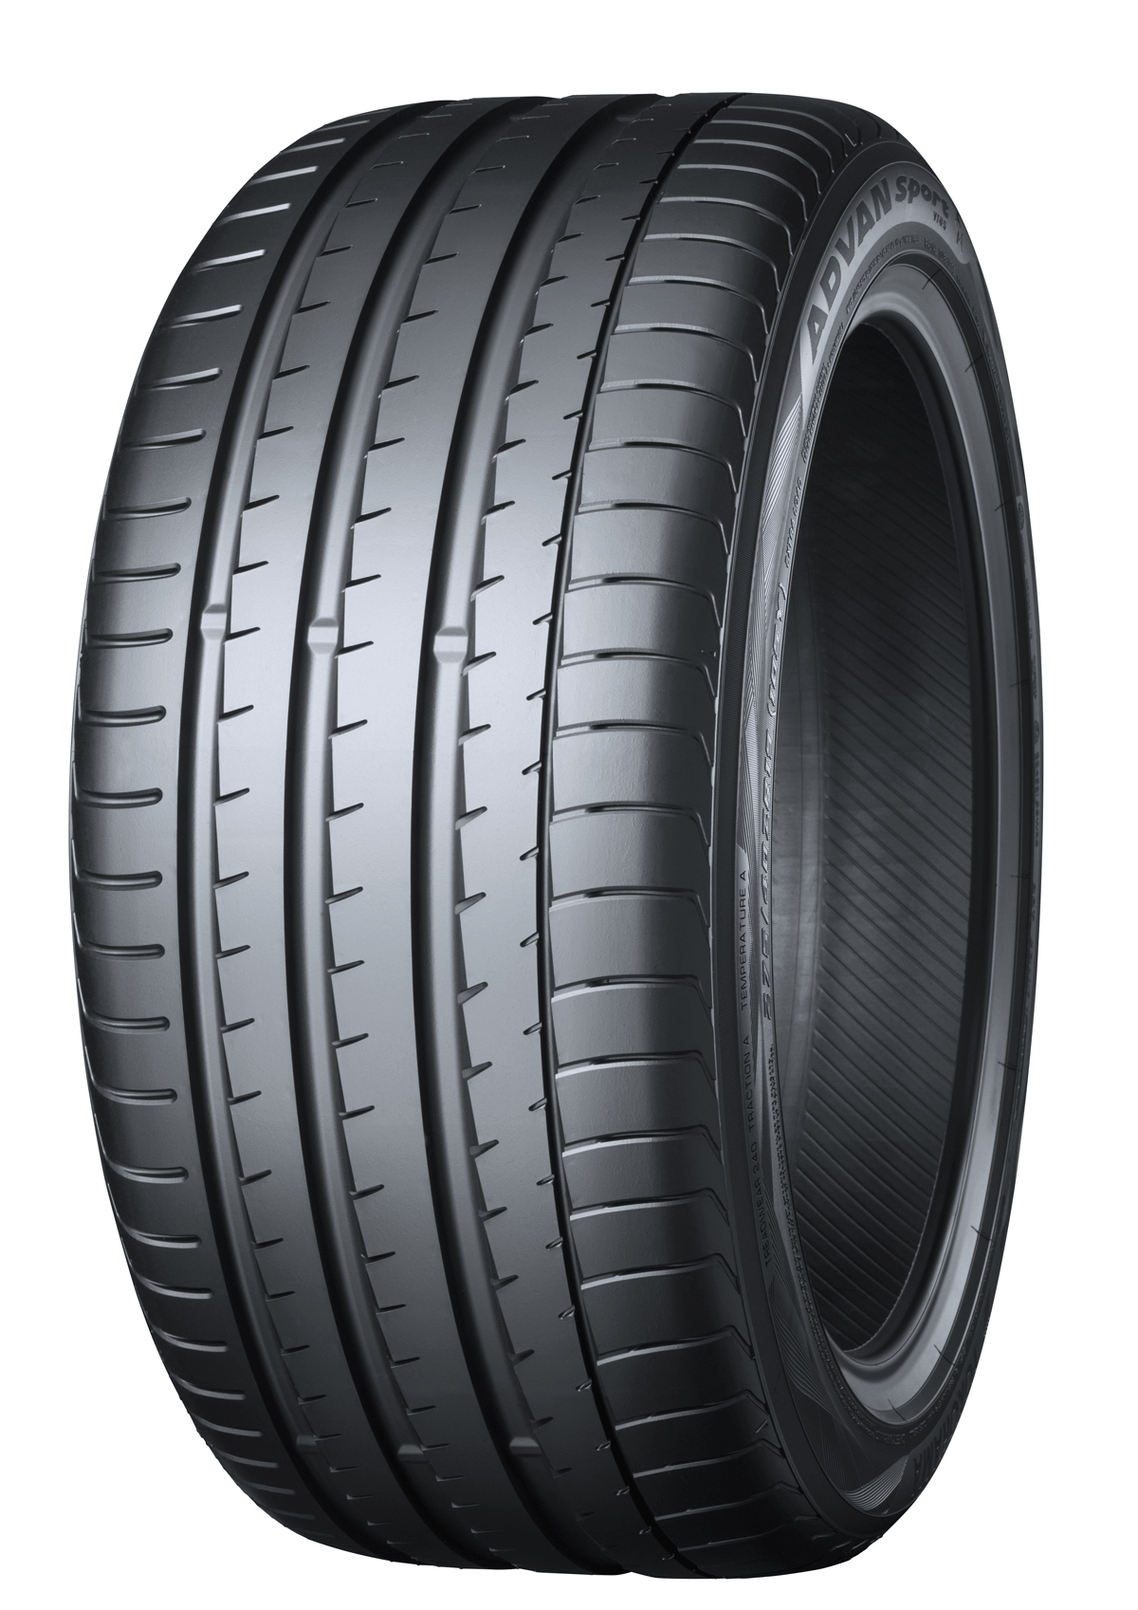
The “ADVAN Sport V105” installed on the new BMW M5. Size:275/40ZR19 (105Y)

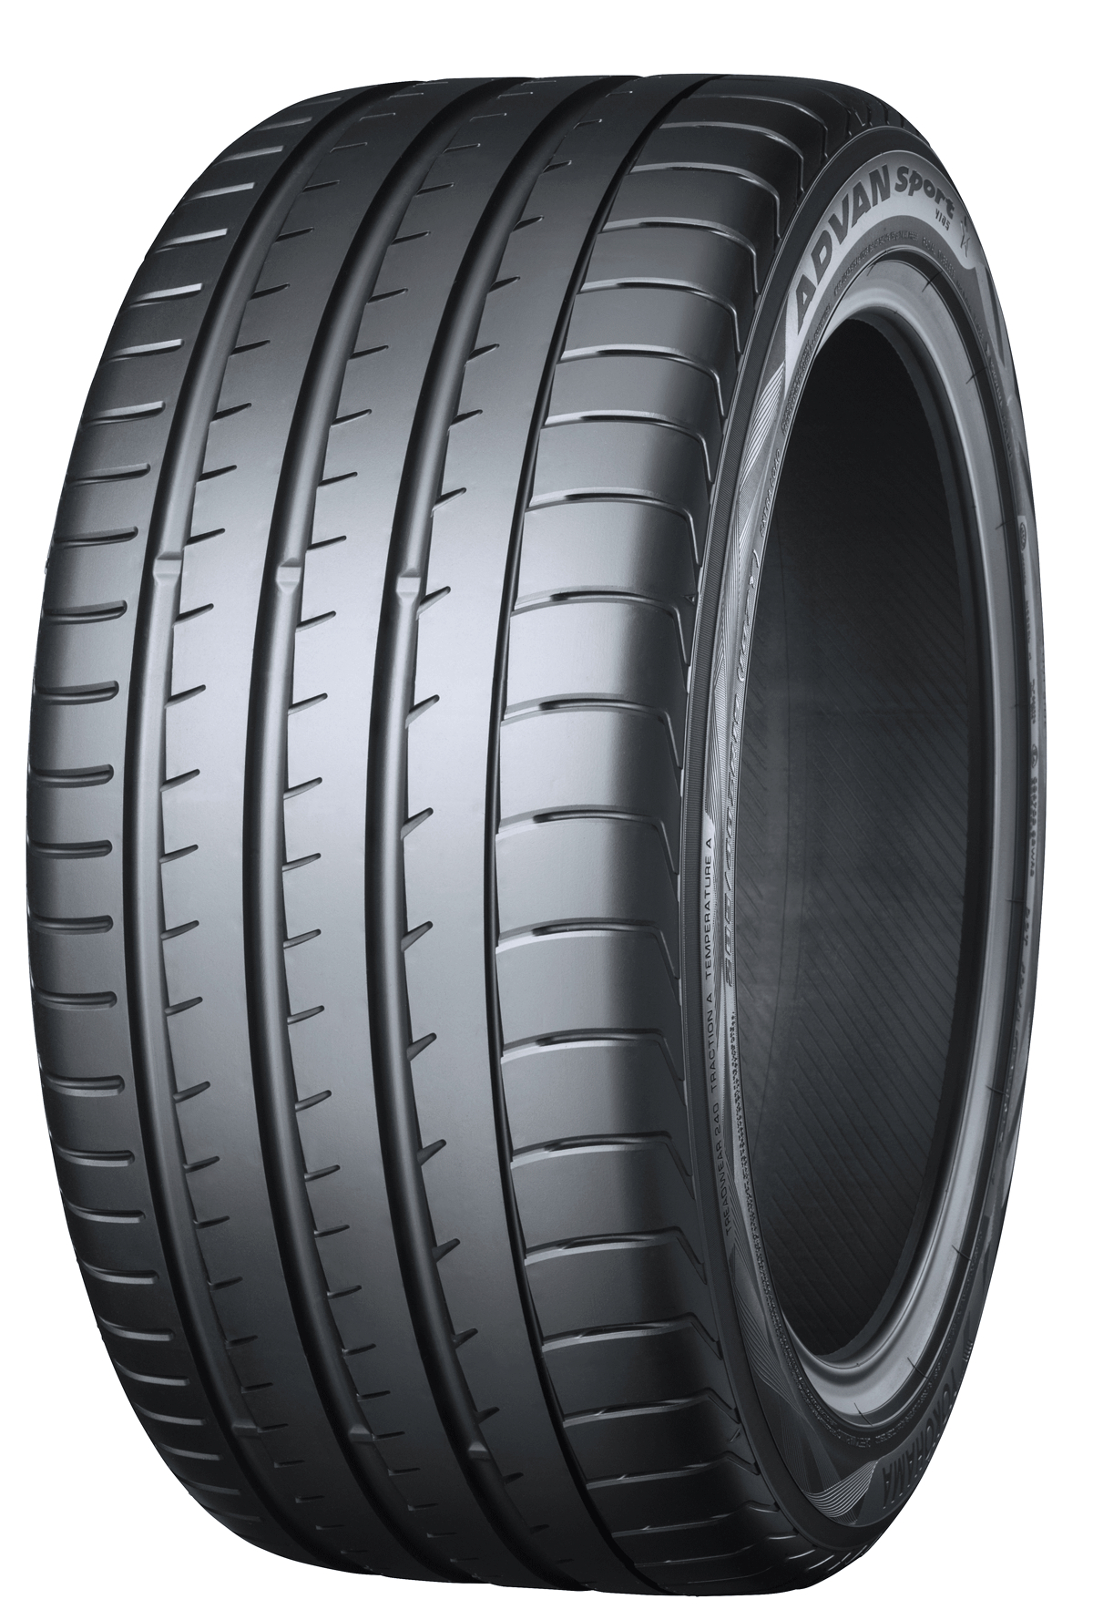

The “ADVAN Sport V105” installed on the new BMW M5. Size:285/40ZR19 (107Y)

